Ex No.: 2
22-01-2015
Software Requirement Specification (SRS) for Exam Registration System

AIM:
To develop a Software Requirement Specification (SRS) for Exam Registration System.
IEEE Format SRS Document:
1. Introduction
1.1 Purpose
1.2 Scope
1.3 Definitions, acronyms, and abbreviations
1.4 References
1.5 Overview
2. Overall description
2.1 Product perspective
2.2 Product functions
2.3 User characteristics
2.4 Constraints
2.5 Assumptions and dependencies
3. Specific requirements
3.1Non-functional Requirements
3.1.1Softwares Used
3.1.2Hardwares Used
3.2Software System Attributes
3.3Software product features
3.4Peformace Requirements

SRS-EXAM REGISTRATION SYSTEM:
1. INTRODUCTION
1.1 PURPOSE: The purpose of the Software Requirements Specification document is to maintain all the functions and the specifications of the Exam Registration System. Besides, it contains the detailed descriptions of all the requirements specified. Exam Registration System provides easy interface to all the users to apply for the exam easily.

1.2 SCOPE:
The scope of this Exam Registration process is to provide an easy interface to the applicants where they can fill their details and the authorities maintain those details in an easy and effective way.
1.3 DEFINITIONS, ACRONYMS AND ABBREVIATIONS
Acquirer: specifies requirements for and accepts delivery of a new or modified software product and its documentation.
Administrator: The one who manages and maintains computer systems and software.
Acronym:
ERS: Exam Registration system.
EXAM REGISTRATION SYSTEM (ERS): The project name.
FAQ: Frequently Asked Questions.
IEEE: Institute of Electrics & Electronics Engineering
IS: Information Systems
IT: Information Technology
Marquee: A piece of text that scrolls across a browser document window.
SDD: Software Design Document
Server: The main computer on a network.
SPMP: Software Project Management Plan
SRS: Software Requirements Specification
Exam officer: The person who works for the exam registration system.
Team: The name of the developer group.
User: People who accesses ERS web site.
Web: the network of computers that forms the Internet.
Applicant/Student: Applicant can register himself by filling out the registration form and finally paying the payment for attending the exam. Database: Database is used to maintain and store the details of registered applicants.
1.4 REFERENCES
[1] IEEE STD 1058-1998, IEEE Standard for Software Project Management Plans
[2] IEEE STD 830-1998, IEEE Recommended Practice for Software Requirements Specifications
[3] IEEE STD 1016-1998, Recommended Practice for Software Design Descriptions
[4] Pressman, Roger S., Software Engineering “A Practitioner’s Approach”, Fifth Edition, McGraw-Hill, 2000.
[5] http://httpd.apache.org/

1.5 OVERVIEW
SRS includes two sections overall description and specific requirements – Overall description will describe major role of the system components and interconnections. Specific requirements will describe roles & functions of the actors.
The overview of the project is to design an exam registration tool for the registration process which makes the work easy for the applicant as well as the Authorities of Exam. Authorities of the exam can keep track of and maintain the database of the registered applicants for the exams.

2. OVERALL DESCRIPTION
This section describes the functions of the project and their aims. It also includes the constraints and the requirements of the project.

2.1 PRODUCT PERSPECTIVE
Exam Registration System provides a online facility to make registration process easy for the end user. Also there will be a database which will keep all the records that is done by user while visiting the page.

2.1.1 SYSTEM INTERFACES
Exam Registration System is connected with University/Exam controller server database, thus no more connection with other systems is needed.

2.1.2 USER INTERFACES
ERS shall be designed as a web based application that has a main user interface. Format of main screen shall be standard and flexible. The system shall be user friendly designed. Pages shall be connected with each other in a consistent way. The design of the pages should allow users to do this.

2.1.3 HARDWARE INTERFACES
There is no need any hardware interface Exam Registration System.

2.1.4 SOFTWARE INTERFACES
1. There are 2 product options for viewing:
A. Name: Microsoft Internet Explorer
Version number: 5.5
Source: Microsoft Corporation, the interface of the ERS is well documented.
Purpose: The web browser specified above is required as the container of the client software at the client site in order to execute the client site of ERS.
OR
B. Name: Mozilla Firefox
Version number: 2.0
Source: Mozilla Foundation, the interface of the ERS is well-documented.
Purpose: The web browser specified above is required as the container of the client software at the client site in order to execute the client site of ERS.

2.1.5 COMMUNICATION INTERFACES
The default communication protocol for data transmission between server and the client is Transmission Control Protocol/ Internet Protocol (TCP/IP). At the upper level Hyper Text Transfer Protocol (HTTP, default port=80, default of apache port=8080) will be used for communication between the web server and client.

2.2 PRODUCT FUNCTIONS
ERS is:
- Login to the system through the first page of the application
- A person(student/educational institute) should be able to Login to the system through the first page of the application
- Change the password after logging into the system
- Should be able to register for the respective course exam enrolled into by providing necessary details.
- Authentication of provided information.
- If valid, the system proceeds to register the person for the exam to be conducted and fee for the examination is deducted.
- Else, try re-submitting to the system.
- He/she will also be able to view their status, details, results ( if any).
- Hall tickets should be manually collected after successful registration from the corresponding management.
10. Logout from the system.

2.3 USER CHARACTERISTICS
The user types that would use the ERS are as follows:
Administrator: Administrators shall usually do anything on the site, in all pages. Administrator is responsible for updating and the maintenance of the web site content such as adding/removing information about the company, adding/removing links onto the main bar, adding/removing Medias in the content menu, adding/removing/updating links on the event calendar and the menu, changing the logo.
User: Users are people who shall use ERS. To use this service people should have the basic computer using ability. User can see all general information, FAQ can use search.
External Users: External users are people who have not got any user account for the web site. They shall use the general information, FAQ.

2.4 CONSTRAINTS
a. Regulatory Policies: There are no regulatory policies.
b. Hardware Limitations: There are no hardware limitations.
c. Interfaces to other Applications: There shall be no interfaces.
d. Parallel Operations: There are no parallel operations.
e. Audit Functions: There shall be no audit functions.
f. Control Functions: There shall be no control functions
g. Higher-order Language Functions: The PHP shall be used for developing the web pages with the help of Macromedia Dream weaver. For the database information, SQL shall be used.
h. Signal Handshake Protocols: This is no signal handshake protocols.
i. Reliability Requirements: Total number of bugs in the system shall not exceed %1 of the total line number of code, except connection reliability which is out of our range.
j. Criticality of the Application: The server applications shall be available 365 days.
k. Safety and Security Considerations: The password and a valid username are the security issues. Data protection shall be satisfied by the backup process at the server side.

2.5 ASSUMPTIONS AND DEPENDENCIES
1. The user must have the ability to use the internet.
2. The user must have connected to the internet to use the system.
3. The user’s computer must be Windows 95 or later version platforms and Microsoft Internet Explorer version 5.5 or later
4. TCP/IP protocol must be installed to communicate through HTTP messages.
5. The accuracy of the information of users is the responsibility of all us

3. SPECIFIC REQUIREMENTS:
The main functionality of registration system is to make the registration and database for it to be maintained in an efficient manner.
3.1 NON-FUNCTIONAL REQUIREMENTS:
3.1.1 SOFTWARES USED:
- Rational Rose/Visual Basic.
3.1.2 HARDWARES USED:
- Intel Pentium processor 3 and above.

3.2 SOFTWARE SYSTEM ATTIBUTES:
3.2.1 USABILITY
User interface makes the Exam Registration system to be efficient. That is the system will help the applicant to register easily and helps the authorities to maintain details effectively. The system should be user friendly.
3.2.2 PERFORMANCE
It describes the capability of the system to perform the registration process of the applicant without any error and performing it efficiently.
3.2.3 RELIABILITY
The Exam Registration system should be able to serve the applicant with correct information and day-to-day update of information.
3.3 SOFTWARE PRODUCT FEATURES:
- Validity Checks: JavaScript provides validity checks for various fields in the forms.
- Sequencing Information: All the information regarding exam details, student list, question details, display of result should be handled sequentially that is data should be stored only in a particular sequence to avoid any inconvenience
- Error Handling: If any of the validations or sequencing flows does not hold true then appropriate error messages will be prompted to the user for doing the needful.
3.4 PERFORMANCE REQUIREMENTS:
This subsection specifies numerical requirements placed on the software or on the human interaction with the software, as a whole. Numerical requirements will include:
- 300 terminals will be supported at a time
- Only text information will be supported (HTTP)
- All the transactions will be processed within seconds.
RESULT:
Thus, an SRS was prepared and drafted successfully after analyzing the Exam Registration System project work thoroughly.
Ex No.: 1
08-01-2015
Problem statement-Exam Registration System

AIM:
Aim of this exercise is to analyze the system to be designed and henceforth, draft the problem statement for Exam Registration System.

PROBLEM STATEMENT:
Study:
To study/ analyze the issues and working of the Exam Registration system in depth and hence, come up with a clean sheet problem statement for the same.
Statement:
This system is proposed to eliminate the hardship of students in registering for their course examination by providing e-registration facility.
Interested students register for the examination fee prior to the due date. The system will check for the authenticity (also eligibility) of the details provided. If found valid, the student gets registered for the corresponding examination else his/her application is declined and the fee gets refunded. The application is sent to the central examination system for verification and validation on successful registration, the student is sent the confirmation message and is assigned a unique registration ID. Hall tickets are issued to the students via corresponding institutions or sent directly to the individual depending upon their course type.
Issues with the hall ticket or error(s) found in updating student details (and other things) can be rectified by intimating the same to the examination officer via the concerned personnel.

RESULT:
Thus, the problem statement for the system to be designed was successfully penned down.

Ex No.: 3
29-01-2015
Use-Case Diagram-Exam Registration System

AIM:
To draw the use-case model by analyzing the actors and relations between them.

USE-CASE DIAGRAM COMPONENTS:

Actors:
1. Student
2. Staff
3. Administrator
4. Database system

Use-cases:
1. Student registration
2. Login
3. Resubmit
4. Manage database
5. View profile
5. Test reports
7. Unavailable

USE-CASE DESCRIPTION:
  - Student: User of the system.
Student registration: The student registration for the examination.

Login: Student login to login to his account after registering successfully.
View Profile: To view the student profile.

Test reports: To view the examination results, if available.

Resubmit: Resubmit is an extension of the student registration. In case of unsuccessful registration, this shall handle that.

Unavailable: This is to display the necessary outcome, if the test reports aren’t available currently.
  - Staff/College officials/Institution: Staff is a user-end actor, who accesses the system for his easy access to register and maintain examination details.
View profile: To view the student’s as well as institution’s profile.

Login: To logon to user’s account via the system.

Test reports: To view the student’s test report. (Belonging to a particular institute).

Student Registration: Sometimes, the institution themselves can register for their students in bulk.
  - Administrator: Administrator will control and monitor the exam registration system. He/she shall have access and control over all the uses of the system. Incase of handling databases, the administrator will do the stuff.
->all actions are notified to the system administrator.
->Incase of any failure/loss of data in regard to the system, administrator will rectify.
4. Database system: To store and retrieve student/ Institution details.
Manage database: Manage Database is to control the load, store and retrieve actions performed on the database effectively.

View profile: The data required is retrieved from the database system using a query and is made visible to user as an output display.

USE CASE DIAGRAM (for the system):

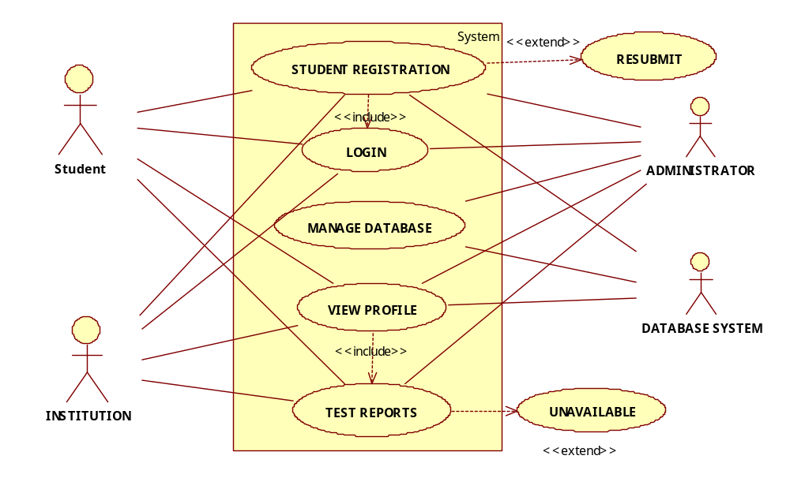

RESULT:
Thus, the use-case model for the system to be designed was successfully drawn using UML.

Ex No.4:
12-02-2015
Activity Diagram-Exam Registration System
AIM:
To draw an activity diagram for the Exam Registration System after thoroughly analyzing the system prospects.

THEORY:

An activity diagram illustrates the dynamic nature of a system by modeling the flow of control from activity to activity. An activity represents an operation on some class in the system that results in a change in the state of the workflow or business processes and internal operation. Because an activity diagram is a special kind of state chart diagram, it uses some of the same modeling conventions.

Basic Activity Diagram Symbol and Notations:

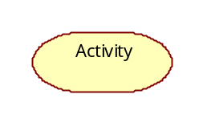
Action states:

Action states represent the no interruptible actions of objects.

Action Flow:

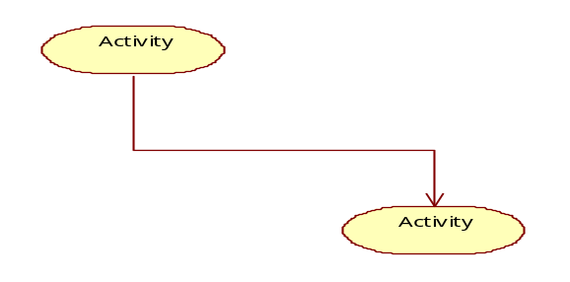
Action flow arrows illustrate the relationships among action states.

Object Flow:

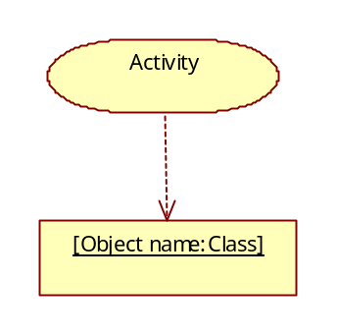
Object flow refers to the creation and modification of object from an action to an object means that the action creates or influences the object. An object flow arrow from an object to an action indicates that the action state uses the object.

Initial State
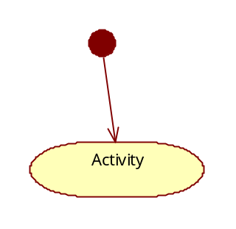

A filled circle followed by an arrow represents the initial action state.

Final State
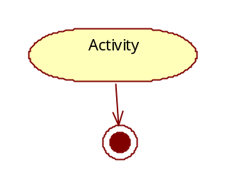
An arrow pointing to a filled circle nested inside another circle represents the final action state

Branching
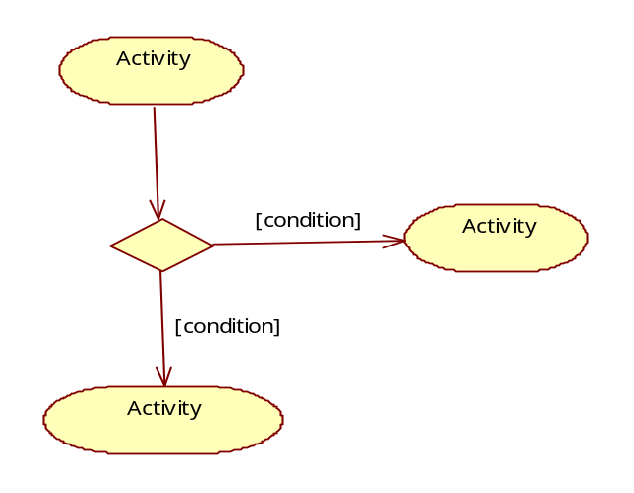
A diamond represents a decision with alternate pa with a condition or guard expression. You can also label one of the paths "else."

Synchronization

A synchronization bar helps illustrate parallel transitions. Synchronization is also called forking and joining

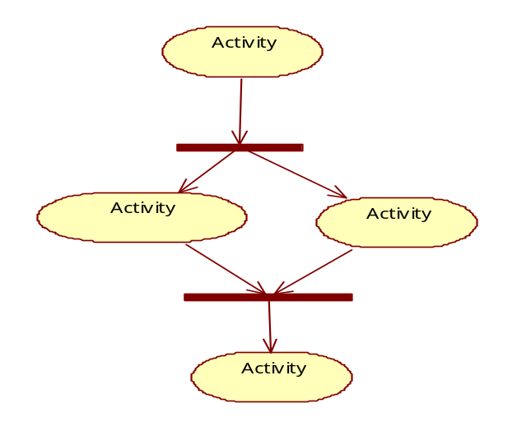

Swimlanes
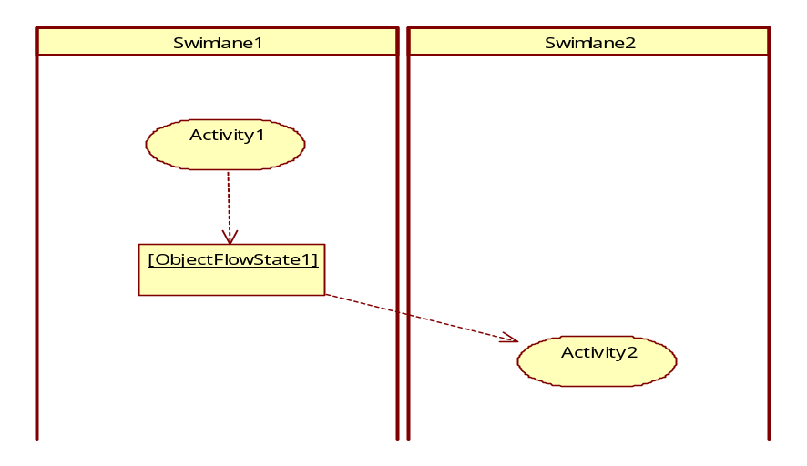

Swimlanes group related activities into one column. Swimlanes group related activities into one column. Activity modeling means to describe sequencing and conditions of actions. Such descriptions commonly are object flow and control flow models.

ACTIVITY DIAGRAM-EXAM REGISTRATION SYSTEM:

Description:
The diagram to follow illustrates the activity flow for Exam Registration system.
We have:
- Swimlanes:
Student: To represent the student object.
Institution: To represent the institution object.
Administrator: To represent the administrator object.
- Activities:
Login: Logging in to the system.
Register: Registering to the system.
Institution Login: Login for the institution.
Verification: verifying the logged on user.
Database store: Storing information or updating the database.
Fee payment: Paying fee verification.
Results: Displaying results if available.
Display profile: To enable user to view their profiles.
Logout: Logging out of the system.

Diagram:
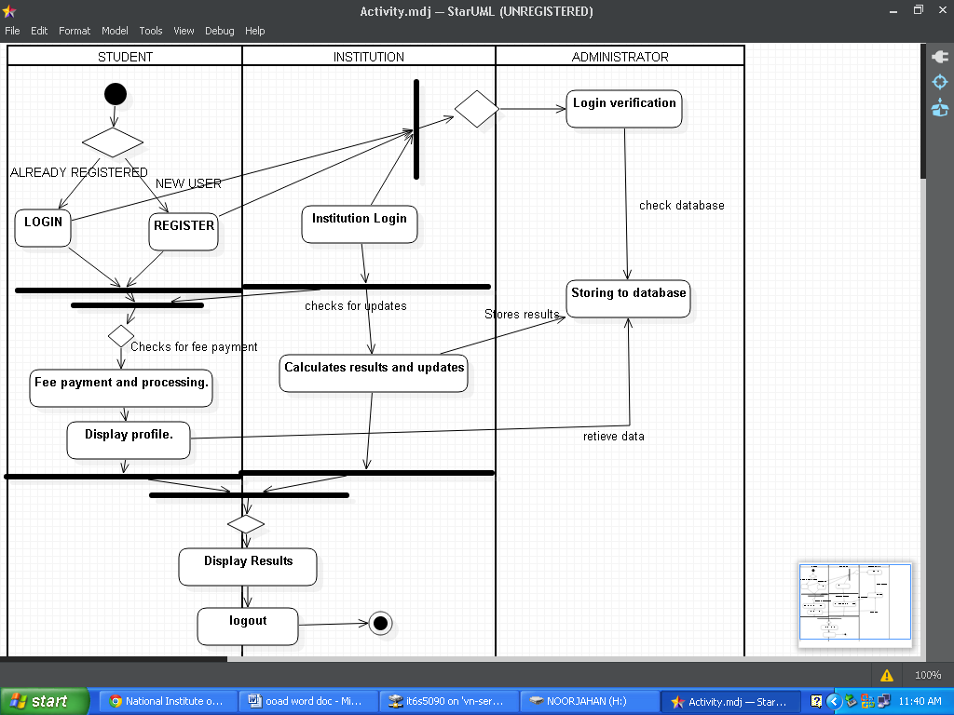
RESULT:
Thus, activity diagram for the system was successfully drawn using UML tools.

Ex No.: 5
19-02-2015
Class Diagram- Exam Registration System
AIM:
To draw the class diagram for Exam Registration System.

THEORY:
Class diagram:
Class diagrams are perhaps the most commonly used diagrams in modeling object-oriented systems. They describe the static structure of a system.

A class diagram shows a set of classes and interfaces, and their relationship.
In an object-oriented system, no class can stand in a complete isolation from all the other classes. Classes share various types of relationship with other classes. In fact, a system is a collection of various collaborating classes. It is through collaboration between various classes that a system can achieve its final goal.

Basic Class Diagram Symbols and Notations:

Classes represent an abstraction of entities with common characteristics.

Illustrate classes with rectangles divided into compartments. Place the name of the class in the first partition (centred, bolded, and capitalized), list the attributes in the second partition, and write operations into the third.

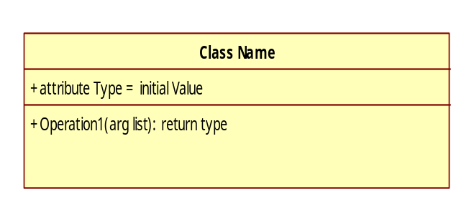
Active Class:

Active classes initiate and control the flow of activity, while passive classes store data and serve other classes. Illustrate active classes with a thicker border.

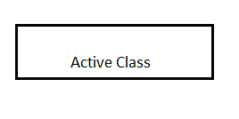
Visibility:

Use visibility markers to signify who can access the information contained within a class. Private visibility hides information from anything outside the class partition. Public visibility allows all other classes to view the marked info information they inherited from a parent class.Protected visibility allows child classes to access information they inherited from a parent class.

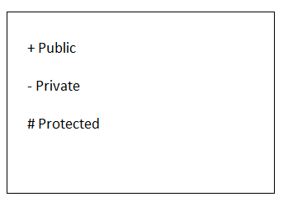

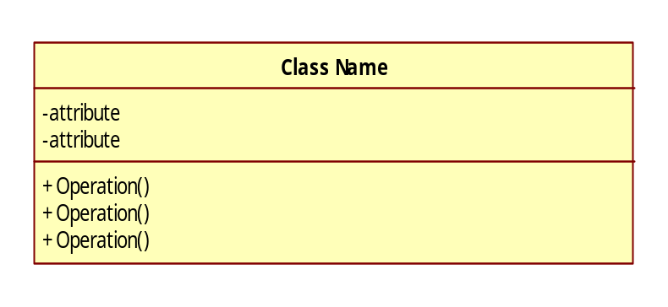
Associations:

Associations represent static relationships between classes. Place association names above, on, or below the association line. Use a filled arrow to indicate the direction of the relationship. Place roles near the end of an association. Roles represent the way the two classes
Note: It's uncommon to name both the association and the class roles.

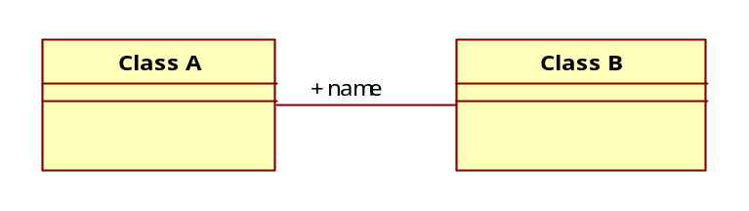

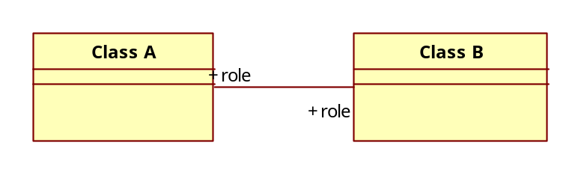

Multiplicity (Cardinality):

Place multiplicity notations near the ends of an association. These symbols indicate the number of instances of one class linked to one instance of the other class. For example, one company will have one or more employees, but each employee works for one company only.

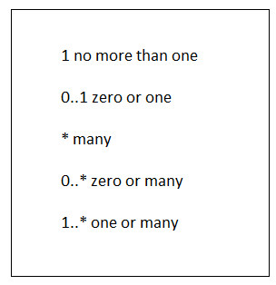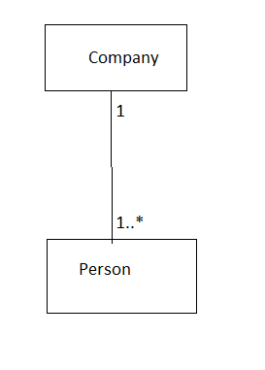

Constraint:

Place constraints inside curly braces {}.
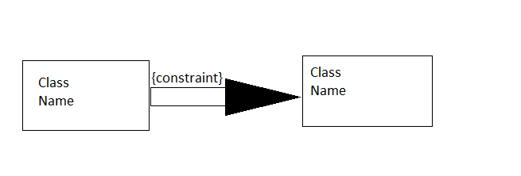

Composition and Aggregation:

Composition is a special type of aggregation that denotes a strong ownership between class A, the whole, and Class B, its part. Illustrate composition with a filled diamond. Use a hollow diamond to represent a simple aggregation relationship, in which the "whole" class plays a more important role than the "part" class, but the two classes are not dependent on each other. The diamond end in both a composition and aggregation relationship points toward the "whole" class or the aggregate.

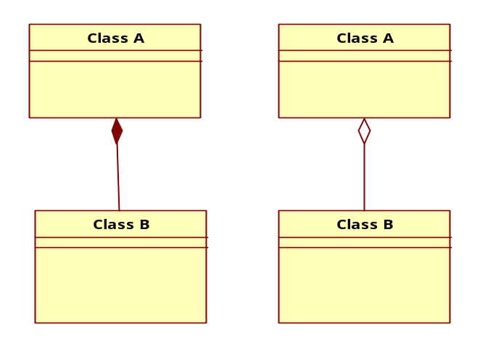

Generalisation :

Generalization is another name for inheritance or an "is a" relationship. It refers to a relationship between two classes where one class is a specialized version of another. For example, Honda is a type of car. So the class Honda would have a generalization relationship with the class car.

CLASS DIAGRAM:

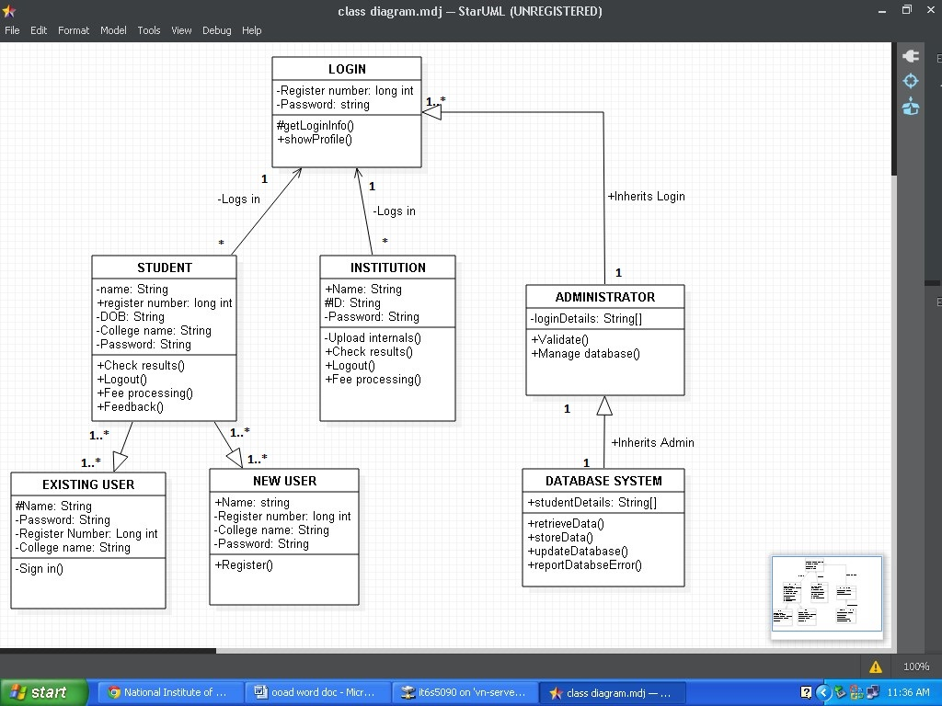

RESULT:
Thus, the class diagram for the Exam Registration System has been drawn successfully using UML.

Ex No.:6
26-02-2015
Interaction Diagram- Exam Registration System

AIM:
To draw the interaction diagram- sequence and collaboration for Exam Registration System.

THEORY:
Sequence diagram:
A Sequence Diagram shows a pattern of interactions among objects, emphasizing the sequence of messages. A message is the mechanism by which an object executes a certain responsibility.

Sequence Diagram demonstrates the behavior of objects in a use case by describing the objects and the message they send.The diagrams are read from left to right and descending.

Asynchronous Message:

The handler returns immediately, but the actual work is done in the background.

Synchronous Message:

The sender waits until the handler completes. This is a normal methods call in a single threaded application.

Notations Used:

Objects are represented using rectangles across the top along with the timeline that when ceases to exit is represented with ‘X’.

Asynchronous Message are represented using ------------------------------>

Synchronous Message are represented using

Messages:

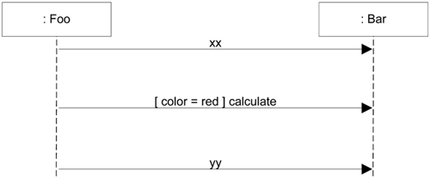

Activation state:

This is used to represent the time when the object is active. (For the processing take place for that object).

Conditions:

A frame box is used to represent an if-else condition based on the decision, the required response message will be sent back to the object.

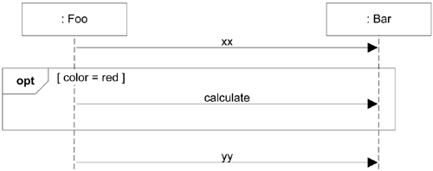

We begin drawing by placing the initial actor at the left and subsequent classes increasing to the right. This shows how object interacts with one another.

SEQUENCE DIAGRAM:

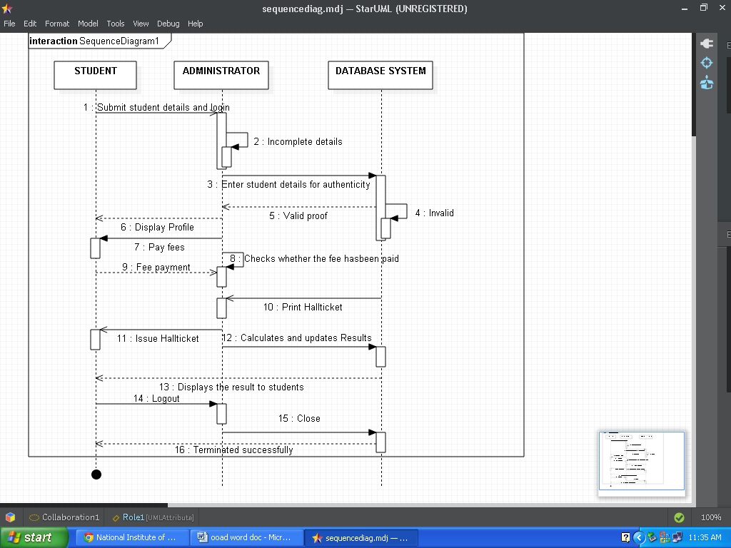

Basic Collaboration Diagram Symbols and Notations:

Collaboration diagram:
A collaboration diagram describes interactions among objects in terms of sequenced messages. Collaboration diagrams represent a combination of information taken from class, sequence, and use case diagrams describing both the static structure and dynamic behavior of a system.

Class roles:
Class roles describe how objects behave. Use the UML object symbol to illustrate class roles, but don't list object attributes.
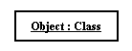

Association roles:

Association roles describe how an association will behave given a particular situation. You can draw association roles using simple lines labeled with stereotypes.
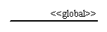

Messages:

Unlike sequence diagrams, collaboration diagrams do not have an explicit way to denote time and instead number messages in order of execution. Sequence numbering can become nested using the Dewey decimal system. For example, nested messages under the first message are labeled 1.1, 1.2, 1.3, and so on. The condition for a message is usually placed in square brackets immediately following the sequence number.

Description:
The following collaboration diagram shows the interaction between the various objects.
The collaboration diagram is similar to the sequence diagram except that the actions/methods are numbered but not ordered, thus making it difficult to find the flow.
The system showcases three classes,
Student: Student object, represents student objects so as to show the interaction between the other objects and student.
Administrator: The administrator object represents an administrator.
Database system: This object represents a database system. This performs the necessary functionalities with regard to the other objects.
The arrow depicts the direction of flow. The interaction is depicted as functions.

COLLABORATION DIAGRAM:

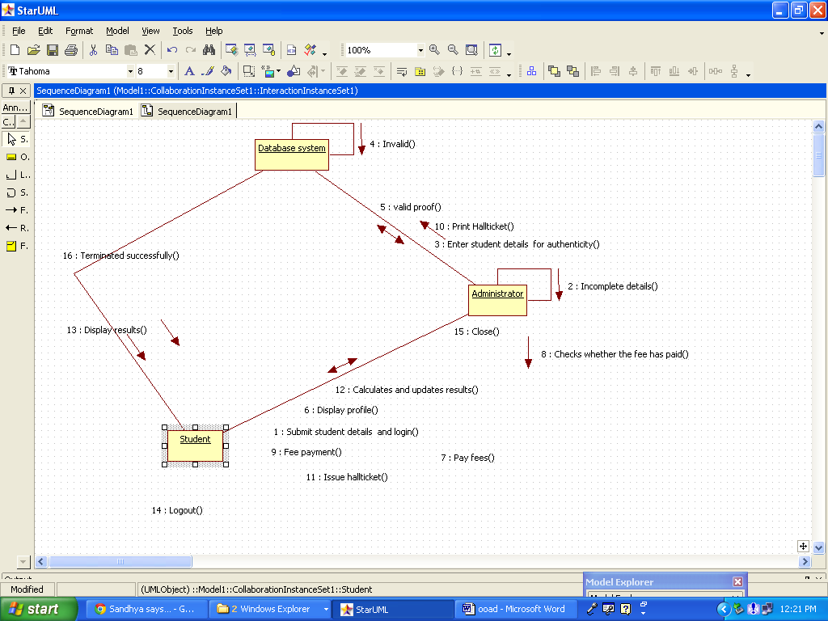

RESULT:

Thus, the interaction diagram was successfully drawn for Exam Registration System.

Ex No.: 7
12-03-2015

State Chart Diagram-Exam Registration System

AIM:

To draw state chart diagram for Exam Registration System.

THEORY:

State chart diagram:

A state chart diagram shows the behavior of classes in response to external stimuli. This diagram models the dynamic flow of control from state to state within a system.
State machines are used to model the dynamic behavior of a model element, and more specifically, the event-driven aspects of the system's behavior are specifically used to define state-dependent behavior, or behavior that varies depending on the state in which the model element is in. Model elements whose behavior does not vary with its state of the element do not require state machines to describe their behavior. In particular, state machines must be used to model the behavior of active classes that use call events and signal events to implement their operations.
A state machine consists of states, linked by transitions. A state is a condition of an object in which it performs some activity or waits for an event. A transition is a relationship between two states which is triggered by some event, which performs certain actions or evaluations, and which results in a specific end-state.

Basic State Chart Diagram Symbols and Notations
States:
States represent situations during the life of an object. It is illustrated by using a rectangle with rounded corners.
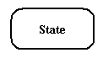

Transition:

A solid arrow represents the path between different states of an object. Label the transition with the event that triggered it and the action that results from it.
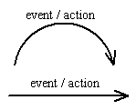

Initial State:

A filled circle followed by an arrow represents the object's initial state.
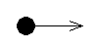

Final State:

An arrow pointing to a filled circle nested inside another circle represents the object's final state.
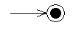

Synchronization and Splitting of Control:
A short heavy bar with two transitions entering it represents a synchronization of control. A short heavy bar with two transitions leaving it represents a splitting of control that creates multiple states.
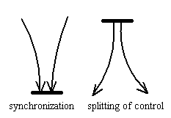

STATE CHART DIAGRAM:

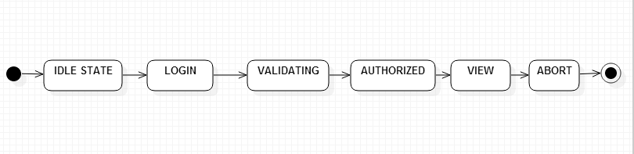

RESULT:
Thus, state chart diagram for Exam Registration System was successfully drawn using UML.

Ex No.: 8
19-03-2015

Package Diagram-Exam Registration System

AIM:

To design a package diagram for Online Bus Ticket Reservation System.

THEORY:

Package diagrams organize the elements of a system into related groups to minimize dependencies among them.

Basic Package Diagram Symbols and Notations:
Packages:

Use a tabbed folder to illustrate packages. Write the name of the package on the tab or inside the folder. Similar to classes, you can also list the attributes of a package.

A package import is "a relationship between an importing namespace and a package, indicating that the importing namespace adds the names of the members of the package to its own namespace. By default, an unlabeled dependency between two packages is interpreted as a package import relationship. In this relationship, elements within the target package will be imported into the source package.

A package diagram in the Unified Modeling Language depicts the dependencies between the packages that make up a model.
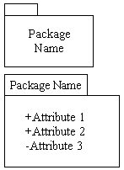

Visibility:

Visibility markers signify who can access the information contained within a package. Private visibility means that the attribute or the operation is not accessible to anything outside the package. Public visibility allows an attribute or an operation to be viewed by other packages. Protected visibility makes an attribute or operation visible to packages that inherit it only.
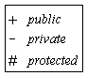

Dependency:

Dependency defines a relationship in which changes to one package will affect another package. Importing is a type of dependency that grants one package access to the contents of another package.
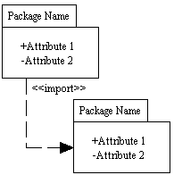

Elements of a Package Diagram:
- Package: A general purpose mechanism for organizing model elements & diagrams into groups. It provides an encapsulated namespace within which all the names must be unique. It is used to group semantically related elements. It is a namespace as well as an element that can be contained in other packages' namespaces.

- Class: a representation of an object that reflects its structure and behavior within the system. It is a template from which running instances are created. Classes usually describe the logical structure of the system.
- Interface: a specification of behavior. An implementation class must be written to support the behavior of an interface class.
- Object: an instance of a class. It is often used in analysis to represent an artifact or other item.
- Table: a stereotyped class.
PACKAGE DIAGRAM:
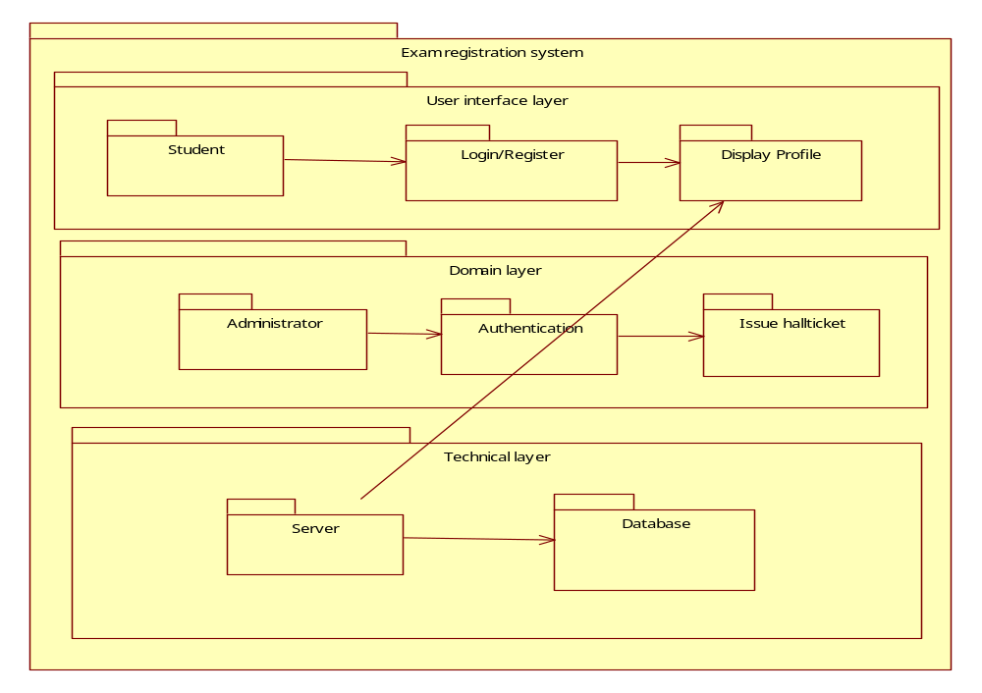
RESULT:
Thus, package diagram for Exam Registration System was successfully drawn using UML.

